Student Club Event Ticketing & Budget Portal

1. Requirements Table
ID | Type | Description | Priority | Acceptance Criteria | Rationale
FR-001 | Functional | The system shall allow Club Leads to submit event proposals containing event name, description, date, expected attendees, and estimated budget. | High | A Club Lead can enter all required details and submit the proposal. The system generates a unique proposal ID and changes its status to Pending Faculty Approval. | Provides a standardized method for clubs to propose events.
FR-002 | Functional | The system shall route submitted event proposals through a multi-stage approval workflow involving the Faculty Coordinator, Finance Officer, and Dean. | High | The proposal moves sequentially from Faculty Coordinator → Finance Officer → Dean after successful approval at each stage. Rejection at any stage changes the status to Rejected and records the reason. | Ensures university events receive proper authorization and financial review.
FR-003 | Functional | The system shall allow authorized users to view and track the status of event proposals and budget requests. | Medium | Club Leads can view their own proposals and see statuses such as Pending, Approved, Rejected, or Budget Allocated. Approvers can view proposals assigned to their approval stage. | Provides transparency and prevents users from having to manually track approvals.
FR-004 | Functional | The system shall generate a unique QR-code ticket for each registered attendee of an approved event. | High | After successful registration, the system generates a unique QR code linked to the attendee and event. Duplicate tickets cannot be generated for the same registration. | Enables secure and efficient event entry management.
FR-005 | Functional | The system shall allow authorized event staff to scan and validate attendee QR-code tickets at the venue. | High | A valid unused QR code is accepted and marked as checked-in. Invalid, expired, or already-used QR codes are rejected with an appropriate message. | Prevents unauthorized entry and duplicate use of tickets.
NFR-001 | Non-Functional — Performance | The QR-code validation API shall process and return a ticket validation response within 100 ms under normal operating conditions. | High | During performance testing, at least 95% of QR validation requests receive a response within 100 ms. | Fast validation is required to prevent queues at event entrances.
NFR-002 | Non-Functional — Security | The system shall ensure that only authenticated and authorized users can access administrative functions and approval workflows. | High | Users without the required role cannot access restricted pages or perform restricted actions. Unauthorized requests are rejected. | Protects university financial information and approval processes.
NFR-003 | Non-Functional — Reliability | The system shall maintain ticket and approval data consistently during concurrent usage. | Medium | Concurrent registrations and QR scans must not result in duplicate ticket IDs or multiple successful check-ins for the same ticket. | Prevents data inconsistencies during high-attendance events.

2. UML Use-Case Diagram

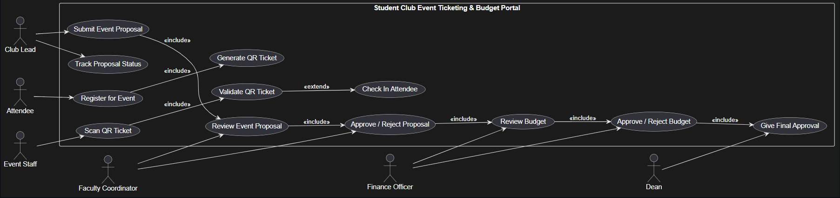

3. Use-Case Flow Specification

Use Case: Submit and Approve Event Proposal

Use Case ID
UC-01

Use Case Name
Submit and Approve Event Proposal

Primary Actor
Club Lead

Supporting Actors
Faculty Coordinator, Finance Officer, Dean

Preconditions
- The Club Lead has a valid account.
- The Club Lead is associated with an authorized student club.
- The Club Lead is logged into the system.
- The event proposal form is available.

Postconditions
On Success:
- The event proposal is stored in the system.
- The proposal receives a unique ID.
- The proposal is approved by the Faculty Coordinator, Finance Officer, and Dean.
- The event status becomes Approved.
- The requested budget is marked as approved.
On Failure:
- The proposal remains in the system with a Rejected status.
- The rejection reason is recorded.
- The Club Lead can view the rejection reason.

Main Success Scenario
- The Club Lead logs into the Student Club Event Ticketing & Budget Portal.
- The Club Lead selects Create Event Proposal.
- The system displays the event proposal form.
- The Club Lead enters the event name, description, date, expected attendance, venue, and estimated budget.
- The Club Lead submits the proposal.
- The system validates all required information.
- The system creates a unique proposal ID.
- The proposal status is changed to Pending Faculty Approval.
- The Faculty Coordinator reviews the proposal.
- The Faculty Coordinator approves the proposal.
- The system forwards the proposal to the Finance Officer.
- The Finance Officer reviews the requested budget.
- The Finance Officer approves the budget.
- The system forwards the proposal to the Dean.
- The Dean reviews the complete proposal.
- The Dean provides final approval.
- The system changes the proposal status to Approved.
- The Club Lead receives a notification that the event has been approved.

Alternate Flow

A1 — Faculty Coordinator Rejects Proposal
- The Faculty Coordinator reviews the submitted proposal.
- The Faculty Coordinator selects Reject.
- The Faculty Coordinator enters a rejection reason.
- The system records the rejection reason.
- The proposal status changes to Rejected.
- The Club Lead is notified of the rejection.
- The workflow terminates.

A2 — Finance Officer Rejects Budget
- The Finance Officer reviews the requested budget.
- The Finance Officer determines that the requested amount is not acceptable.
- The Finance Officer rejects the budget and provides a reason.
- The system records the rejection reason.
- The proposal status changes to Rejected.
- The Club Lead is notified.
- The workflow terminates.

